# Introduction

For my final project in GEOG 657 - Web Programming, I decided to create a professional portfolio. The link to the final output can be found here:[https://osheak.github.io](https://osheak.github.io/). My husband, Patrick O’Shea, is currently in a career transition from water resource engineering to geospatial analysis/web development. He has spent years creating and refining hydraulic models for consulting companies, however GIS has always been his first love. Since his undergraduate degree in Geography and GIS certificate, he has utilized those skills to enhance his engineering by creating maps, delineating basins, and processing DEM data. As he looks for a permanent geospatial analyst/developer position, he needs a place to highlight his skills and communicate his experience to potential employers. My objective was to create a portfolio website for him that was professional and engaging.

Patrick had a variety of needs for this website. Firstly, he needed it to communicate who he is, what experience he has, his vision for his career, and how to contact him. This included the ability to direct people to his work relevant social media, e.g. Linkedin and Github. Next, he needed a way to showcase work products he has made that demonstrate his relevant skills. This includes maps, apps, and tools. Lastly, he needed an engaging way to communicate the breadth of different projects he has worked on.

The target audience for this website is mid- to senior- level geospatial/data science managers from government, private, and non-profit organizations. They work in the natural sciences and are looking to hire highly-skilled, reliable, early-mid career professionals. I wanted to make sure that the website had an aesthetic focus that felt fresh, environmental, and graphic.

# Data Description

I collected data around the projects that Patrick has worked on during his career. This includes attributes such as Project Name, Project Summary, Relevant Links, Skills Utilized, Latitude, and Longitude. This was originally planned to be a database in MySQL, however I pivoted to adding this data directly as markers to the interactive map page using javascript.

**Table 1.** Database Information

| **Project Name** | **Project Summary** | **Relevant Links** | **Skills Utilized** | **Latitude** | **Longitude** |
| --- | --- | --- | --- | --- | --- |
| Diurnal variations in the spatial patterns of air pollution across Delhi | We have analyzed the spatial patterns of seasonal-scale diurnal cycle of three main pollutants, NO2, SO2, and O3, across five stations in Delhi. We used hourly data collected by the local pollution monitoring agencies for the time period, October 2010 to September 2013. Harmonic analysis was used to detect the diurnal cycle in the observed patterns of pollutants across Delhi… | <https://link.springer.com/article/10.1007/s00704-015-1441-y> | Spatial Analysis  Cartography  Data Analysis  Field Observations | 28.7041 | 77.1025 |
| Borrego Canyon Road Geology Using Magnetic and Gravity methods | As part of the Summer of Applied Geophysics Experience (SAGE), We conducted a magnetic and gravimetric survey of the Borrego Canyon Road near Santa Fe, NM. Gravity survey indicates that changes in gravity are mostly due to elevation trends along the road, with some influences due to geologic transition from ancestral rio grande deposits to quaternary alluvium. Magnetic trends indicate an increase in magnetic signature towards the north west, aligning with the known geologic transition. | <https://www.linkedin.com/in/pmoshea/details/experience/51035385/single-media-viewer/?profileId=ACoAAByKnO0BUiSHp29xlaLEEOtI18O0FvAAzrg> | Spatial Analysis, Field Survey, Data Analysis, Modeling | 35.687 | -105.9378 |
| The Effect of Dune Slopes and Material Heterogeneity on the thermal Behavior of Dune Fields in Mar's Southern Hemisphere | We analyzed patterns in apparent thermal inertia (ATI) in three dune fields in Mars' Southern Hemisphere. We used High Resolution Imaging Science Experiment (HiRISE) 1m DEMs of the martian surface and MARSThERM to model ATI for slope mixtures, gran-size mixtures, and layered surfaces. Results indicate that ATI behavior is sensitive surface layering and the presence of duricrusts, while less so to slope and aspect. | <https://www.linkedin.com/in/pmoshea/details/experience/1536206853857/single-media-viewer/?profileId=ACoAAByKnO0BUiSHp29xlaLEEOtI18O0FvAAzrg> | Spatial Analysis, Cartography, Data Analysis, Modeling | 40.01499 | -105.27055 |

# Website Description

I wanted to focus on responsive design when creating the portfolio website. I decided to utilize Materialize as the framework for responsive design and elements. This allowed me to control how content is presented on various sized screens. Along with javascript, materialize allowed me to control how the navigation bar changed to a dropdown when on small screens.

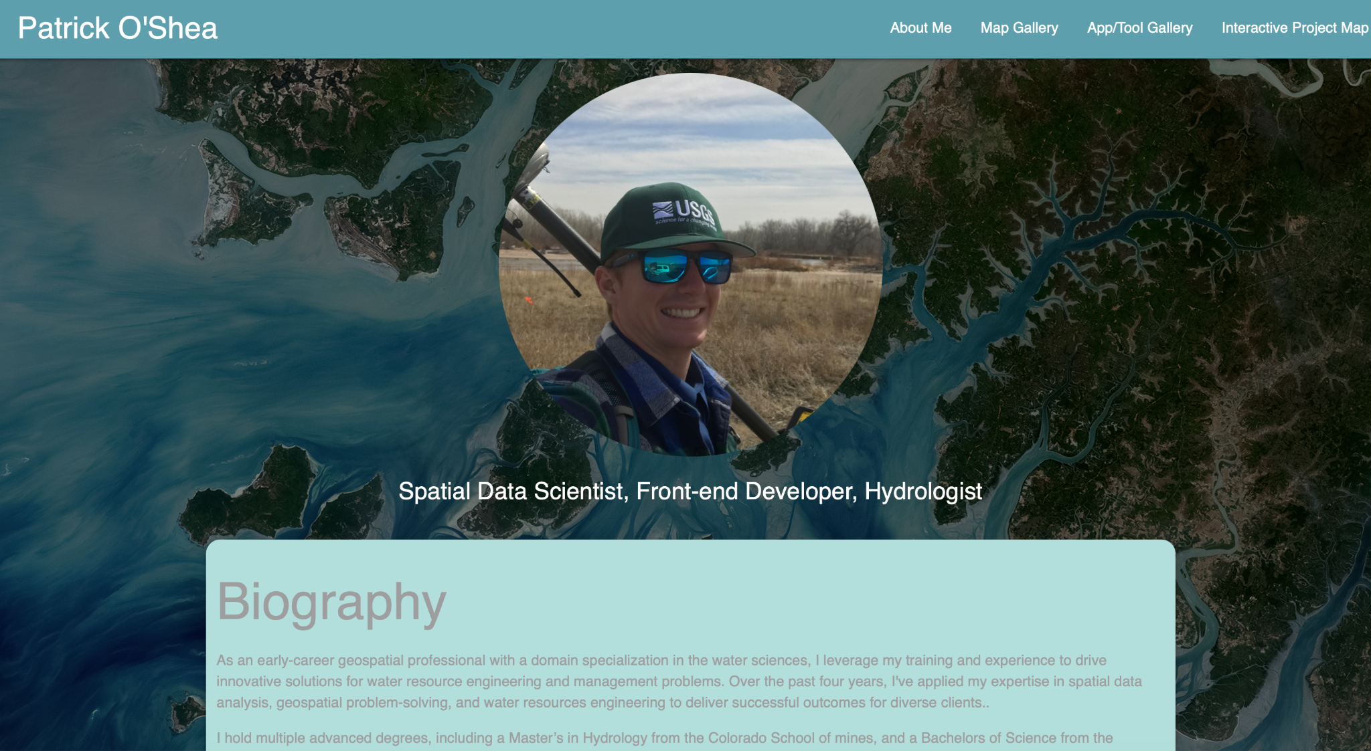

**Figure 1:** The ‘About Me’ page that users first see when visiting Patrick’s Professional Portfolio website.

*Webpage 1 - About Me*

My aim with the ‘About Me’ page was to provide relevant professional information and various avenues to connect (email, linkedin, github). To implement this, I started by defining a navigation bar. This was positioned at the top of the page and provided a title and links to each page in the website. Then I added a photo and some descriptive position titles. As I added content such as a biography, career objectives, etc., I used card panels to highlight the different sections. I gave them different colors, lightened them by 4, and used a span tag to apply gray text. I used an unordered list to group skills & proficiencies that were similar. I used the Materialize gridding to put the download cv section and contact me section beside each other on large screens (s12 m6 l6). I added buttons linked to open his CV or to direct the viewer to his linkedin or github page. I used css to set the background as an engaging remote sensing image and format the photo of Patrick to not be stretched. I also used it to specify the shape and size of the card panels and parameters of the Nav bar.

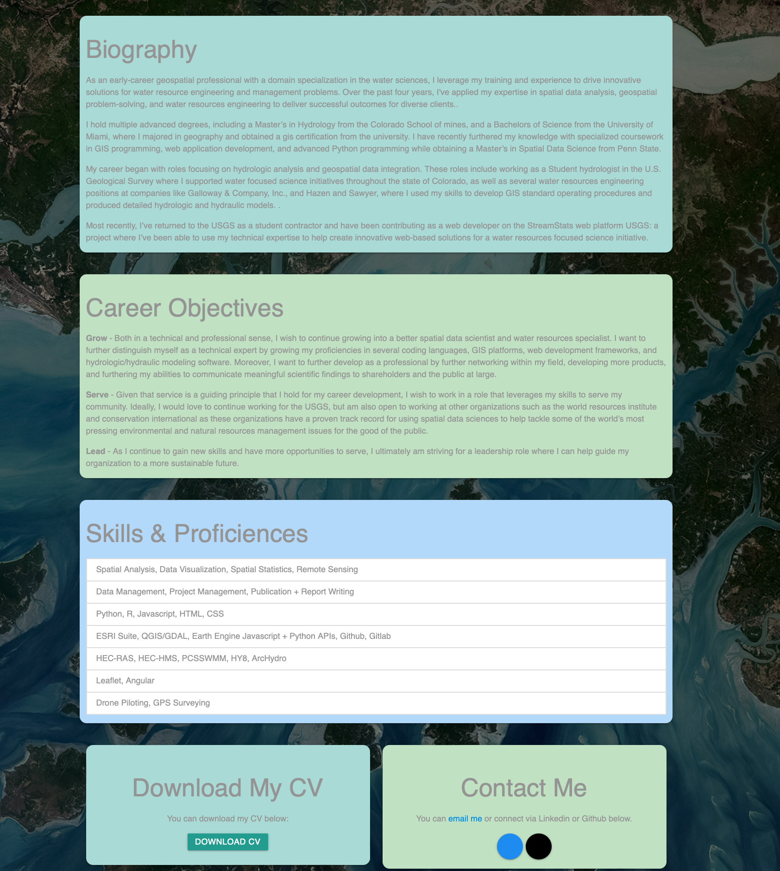

**Figure 2:** Content for the ‘About Me’ page highlighted by section and organized using Materialize grid system.

*Webpage 2 - Map Gallery*

My aim with the ‘Map Gallery’ page was to create a format that showed off Patrick’s cartographic skills by showcasing different maps and providing descriptions for each. I choose to utilize the materialize card functionality to highlight each map in a gallery like format. I set it to s12, m6, l6. Additionally, I decided to add tab functionality to be able to provide more detail for each map example (see example).

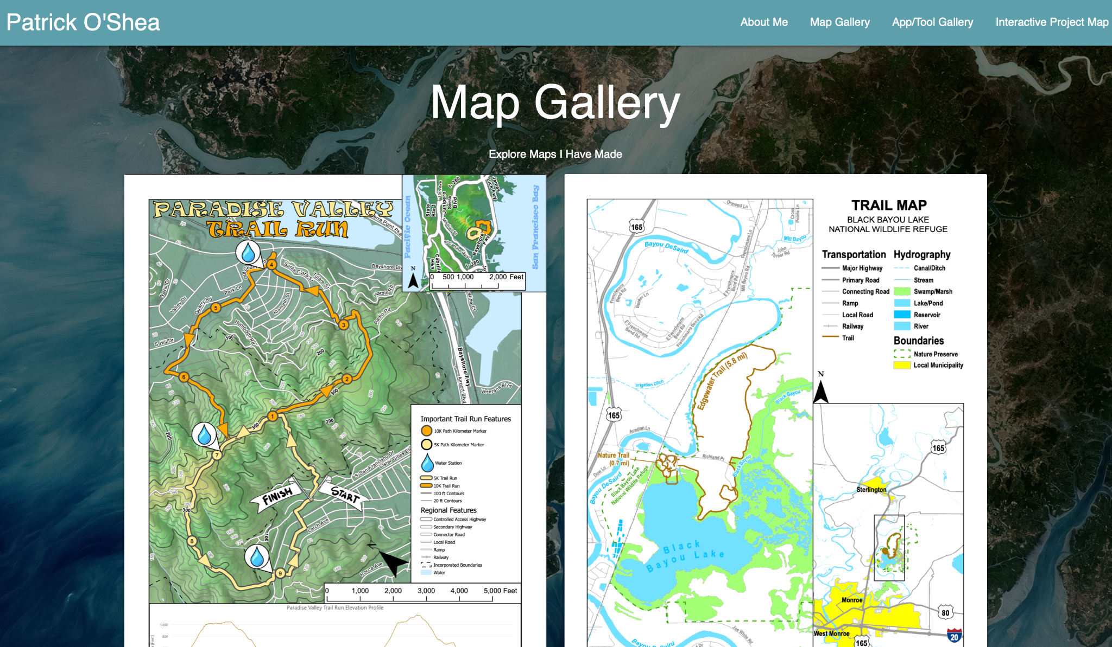

**Figure 3:** The ‘Map Gallery’ page with Materialize card functionality for each map that has tabs showing map title and map description.

*Webpage 3 - App / Tool Gallery*

My aim with the ‘App/Tool Gallery’ page was to highlight more dynamic products that Patrick has created like Apps and Tools. I utilized the same functionality as the ‘Map Gallery’, and added an additional tab for links to the apps or github hosting of the tools.

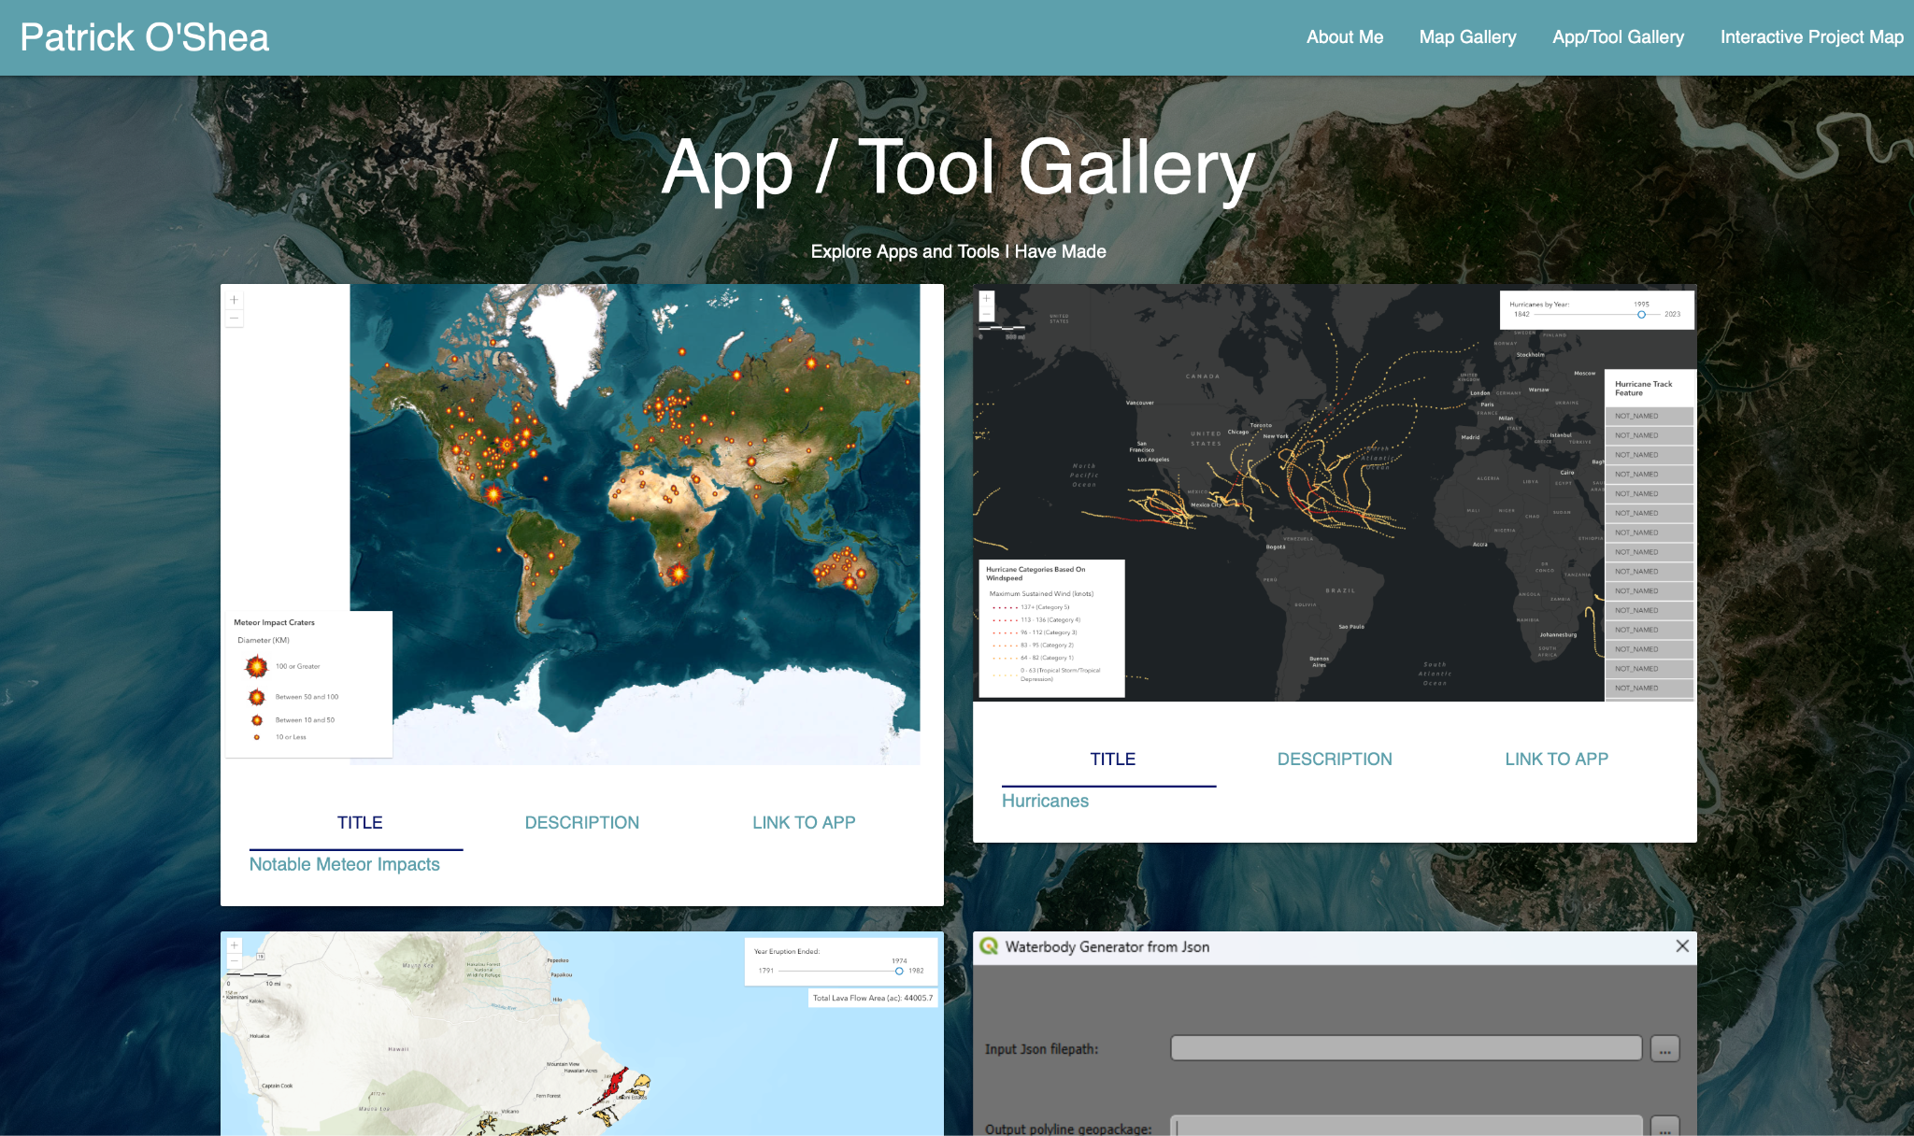

**Figure 4:** The ‘App/Tool Gallery’ page with Materialize card functionality for each app/tool that has tabs showing app/tool title, description, and link.

*Webpage 4 - Interactive Project Map*

Pat has completed projects across many different locations. I thought an interactive map would be a good way to conceptualize that variety of experience with different locations. I utilized leaflet for adding the interactive map to the page. I used javascript to initialize the map as well as create and add markers with pop-up content. I used css to set the map height and margin.

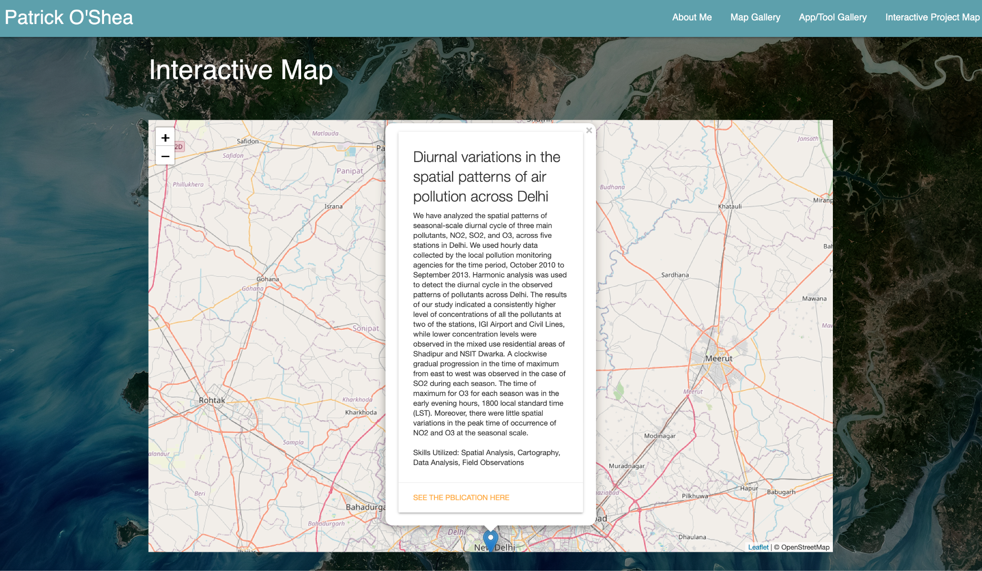

**Figure 5:** The ‘Interactive Map’ page with leaflet map and markers with project details.

# Conclusion

The final website is being hosted by Github pages and can currently be explored at: <https://osheak.github.io/>. It will continue to be refined and eventually be hosted at https://osheap.github.io/. This will allow for free hosting and version control as the website is updated.

Future improvements include 1) brainstorming the best way to highlight scripts and script outputs that don’t have gui’s, 2) adding new projects as completed, 3) continuing to refine dynamic aspects that improve user experience. My client was happy with the website and will be using it as his professional portfolio moving forward.